# Lab: Ownership Chain

|  |
| --- |
| * This is an in-class lab, and worth 10 points. * This is due on Saturday, March 28, 2020 at midnight. * Use the following naming convention: homework, underscore, last name, first initial, and extension (e.g., Lab_Ownchain_ImG.docx). |

* (**Task 1**) Show the outcome of this task in a screenshot. Also, explain briefly why you have received that result.

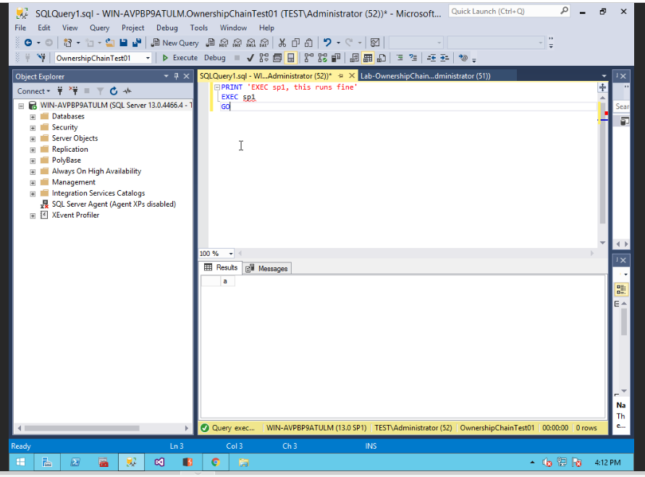

This runs fine since TestUSER01 has execute authority on sp1.

* (**Task 2**) Show the outcome of this task in a screenshot. Also, explain briefly why you have received that result.

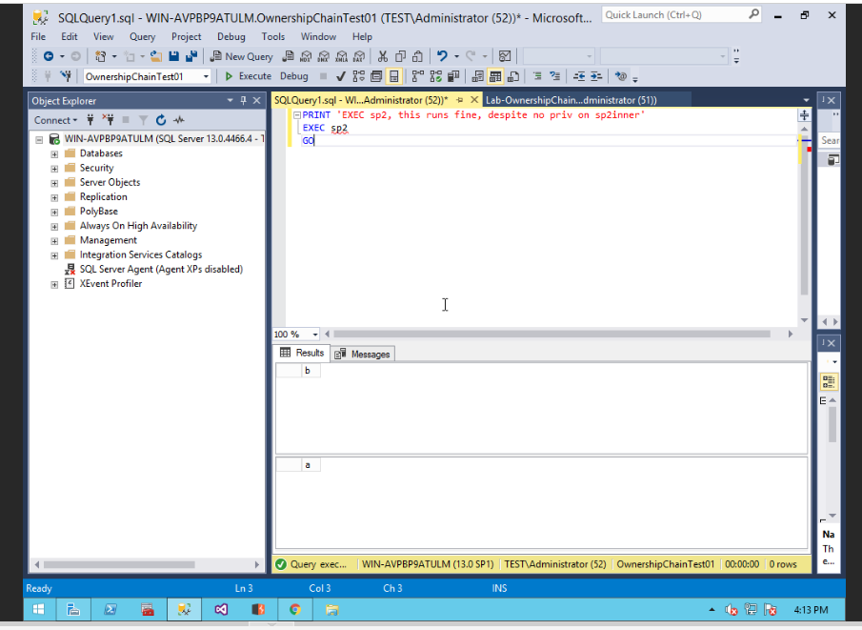

This runs fine since TestUSER01 has execute authority on sp2.

* (**Task 3**) Show the outcome of this task in a screenshot. Also, explain briefly why you have received that result.

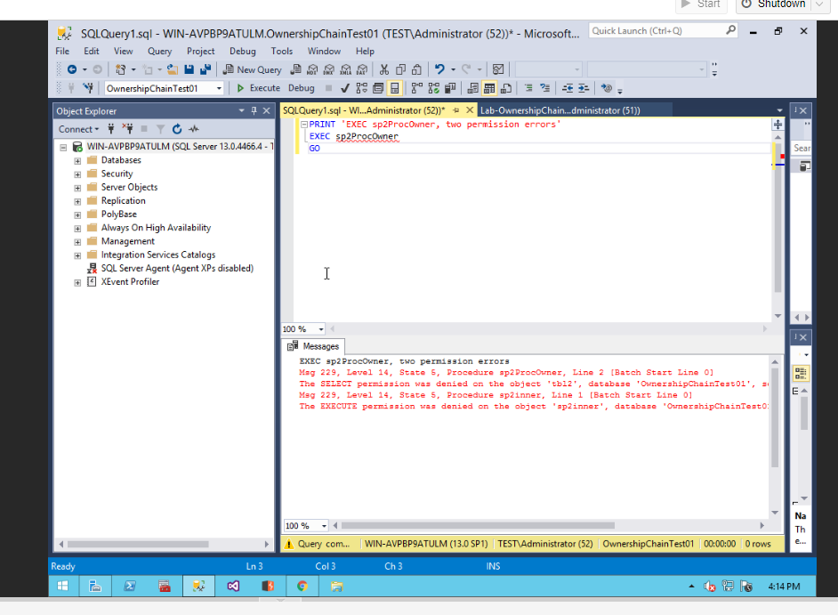

This fails since we altered sp2ProcOwner to only be authorized to user ProcOwner01

* (**Task 4**) Show the outcome of this task in a screenshot. Also, explain briefly why you have received that result.

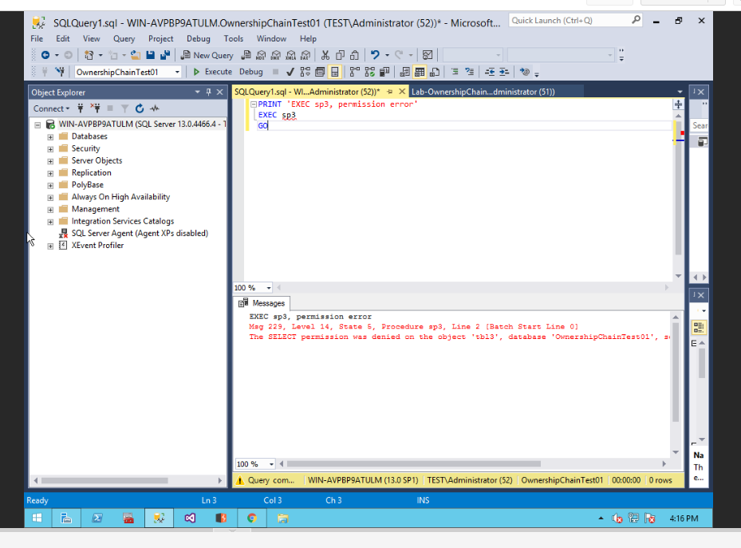

This query fails since the command gives a permission error preventing the user from access this stored procedure

* (**Task 5**) Show the outcome of this task in a screenshot. Also, explain briefly why the result is different from the one from Task #4?

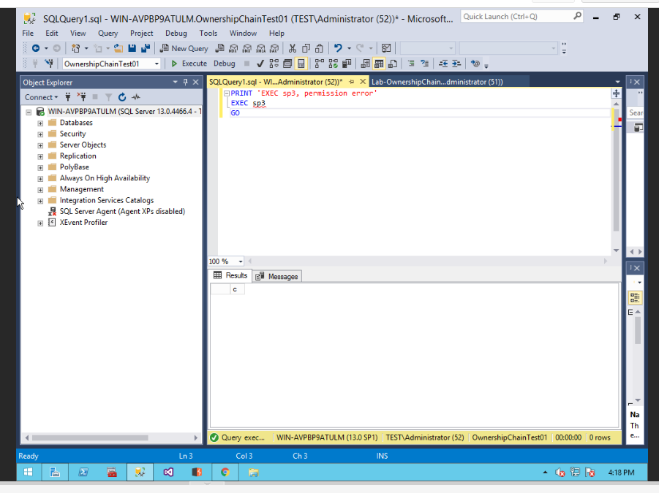

The outcome is different since the sysadmin account has all the required permissions to perform the query unlike TestUser01.